KD0003 Yellow Coding Robot Bluetooth APP

**Installation Method For Iphone:**

1. Open App Store

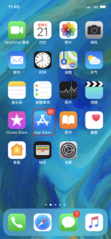；

2. Search “Coding Robot” in App Store 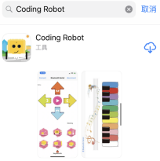；

3. Click “Download”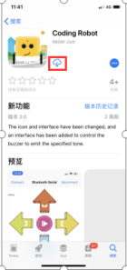，after downloading and open 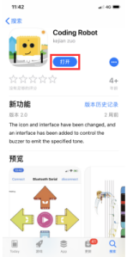 app，the home page comes up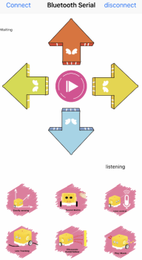；

4）Power on the yellow coding robot, start the Bluetooth of coding robot and cellphone. Click “Connect” to pair. 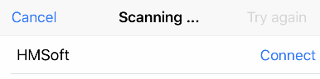comes up, identify the Bluetooth name of the coding robot, and click "Connect" to connect, and then you can send and receive signals.

**Installation Method For Android System:**

Android System (Overseas)

Download Link：

https://play.google.com/store/apps/details?id=com.keyestudio.codingrobot

Android System (Domestic)

Download Link：

<https://pan.baidu.com/s/1w1R5eam6a-FX6Isc8ijk5g>